Citizenship in a Digital Era
International Training Course for Youth Workers
FINAL REPORT
Photo Story Link HERE which highlights the outputs of the training activities
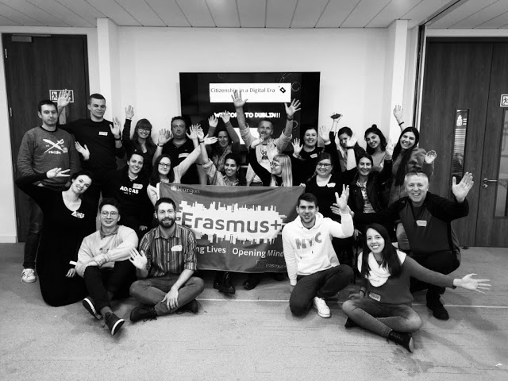

Hosted by the National Youth Council of Ireland and supported by Leargas
Contact in the National Youth Council of Ireland: Jean Marie Cullen international@nyci.ie
Contact in the Irish NA: Carmel Walsh cwalsh@leargas.ie
Trainers: Nora Furlong & Daragh Kennedy
Dates 07 – 10 /05/2019
Event venue: Irish Human Rights and Equality Commission Building, Dublin, Ireland
Number of participants: 21
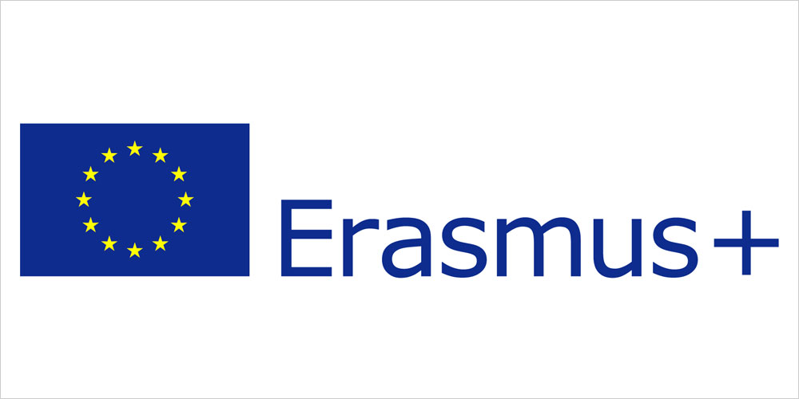
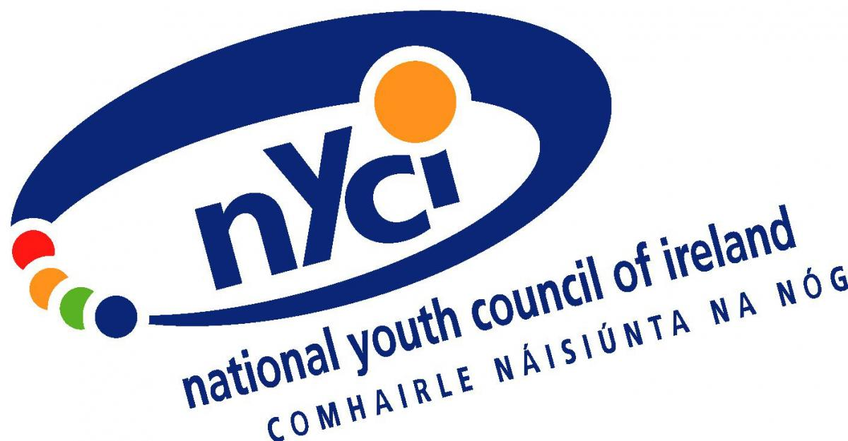

Profile of Participants:
The Target group in the Salto call was as follows: Youth workers, Youth leaders, Youth project managers, Youth coaches, anyone working with young people/ youth led media organisations
Themes and Goals of the Training Programme:
The main aim of this training was to equip youth workers from Europe with the tools to increase the levels of media literacy amongst the young people that they work with and support them to be responsible digital citizens.
Mainstream Media has a very important role in shaping perspectives and attitudes in society. Without the necessary critical thinking skills and media literacy skills discriminatory views can be easily influenced. This training programme was designed to equip Youth Workers to challenge youth workers in this area so that they can engage young people in their sense of digital citizenship.
Objectives of the Training Programme:
- To explore and develop an understanding of key concepts
- To equip youth workers with creative tools, activities and methodologies exploring media literacy, digital citizenship and the promotion of intercultural and diversity competences and understanding.
- To explore the issue of Hate Speech.
- To develop participants skills to analyse and evaluate power and impact of media images and messages.
- To develop participants’ abilities to produce alternative media messages that promote diversity and inclusion.
- To explore further possibilities of projects and cooperations on this topic within the framework of the Erasmus+ programme.
Expected Results:
The anticipated results from the training programme were as follows;
- The participants to leave the training with increased confidence to be able to incorporate digital citizenship projects and awareness programmes in their youth work practice.
- The programme would be flexible to try to meet the training requirements of all the participants.
- The methods that were used could be taken away and used by the participants in their youth work practice.
- The participants would develop their networks and commence the process for developing further partnerships and projects in the area of digital citizenship across Europe.
- The participants would leave with a greater understanding of how the Erasmus + programme can support their future work with young people.
Costs: Coordinating organisations (IE and Denmark NA’s) covered all hosting costs. Sending NAs to travel return travel costs only.

Citizenship in the Digital Era – Final Programme Grid
7th – 10th May 2019
Trainers: Nora Furlong & Daragh Kennedy

Day 1 | Tuesday
Time | Contents of the session | Objectives of the session | Method and tools of implementation
11am | Registration & Coffee
11.15am | Session 1  Welcome and Introductions  A word from our sponsors – NYCI/Leargas  Programme Introduction & Aims of TC  Getting to know each other - Interactive  Hopes and Expectations for the TC  Working Together Contract | Welcome address from NYCI/Leargas  To support people to start to get to know who is in the room  Focus on what they want from the TC leading to the creation of a working contract that will help us deliver on the expectations. | Jean-Marie Cullen from National Youth Council of Ireland welcomed the participants and gave a brief input into the work that NYCI do on this topic. NYCI has hosted various international seminars and research projects such as Screenagers International Research project and digitalyouthwork.eu. The Department of Children and Youth Affairs nominated NYCI to the EU Commission Expert Group on Digitalisation and Youth, which recently produced a report on Developing Digital Youth Work. We provide various training for youth workers including STEAM in Youth Work, Web safety in Youth Work and Understanding Young People and Pornography. We also host the No HateSpeech movement in Ireland nohatespeech.ie. NYCI is a member of the steering committee for Media Literacy Ireland. See www.youth.ie or contact international@nyci.ie for more details.  Interactive sharing of names, organisations, nationalities etc.  Options? Human Bingo / Citizenship themed games  SDG BINGO NORA Resource HERE P21  Profile/Passport Exercise – PAX work together to design profile pictures of each other. The key pieces of information that they obtained from each other included their favourite App, what they do to relax, the most famous person they follow online etc.  Individual reflection naming what their Gives & Gets for the TC, write them on post its and place them on the chart. Present them back in plenary.  Open discussion agreeing a working together contract key elements of confidentiality, participation, respect, allowing space for yourself and others to explore the issues etc
1pm | Lunch
2.30pm | Session 2  Defining citizenship | Establishing what citizenship means to the PAX and exploring a values approach to their work with young people. | Introduce this with a short definition of citizenship  The Character of an individual viewed as being a member of a society... dictionary.com  Part 1  In country groups explore what does it mean for me to be a citizen in my country.  Write words that come to mind on an A4 sheet i.e.  Rights, responsibilities, to be kind, abide by the law, vote, contribute to society, keep myself and others safe, pay taxes, look after my family etc...  Role - Safety - Responsibilities -  Values - Customs - Rights - Identity - Status -  Break it down based on a national - regional - local basis.  Mix the countries up in small groups of 3 and share with each other the top three ideas that they have captured.  Identify commonalities and differences that they see. Work together to demonstrate the commonalities and differences in a plenary presentation. Silent statues and others guess what is going on??  Part 2  Look at what digital citizenship is. Ask them to go back in to their groups and look at how they portray those characteristics online. Ask them to make a [mind map] that can be presented in plenary.  Silent floor where people go around and view what has been produce.  Debrief in plenary
4pm | Coffee Break
4.30pm | Session 3  The Competent Youth Worker in nurturing resilience and Active Digital Citizens  Case Study ; Kelvin from No Hate Speech CoE campaign run by NYCI | Head Heart Hand Exploration  how can young people build resilience & contritute on-line | The group are split in 3.  Each group have a different focus:  - Values  - Knowledge  - Skills  We then fed back into the entire plenary

Day 2 | Wednesday
Time | Contents of the session | Objectives of the session | Method and tools of implementation
11:30am | Session 4  Theory, ethos and ethics of online campaigning | Exploring the role of campaigning with young people – how can we support them to use their digital/social media skills to lead social campaigns? Develop strategies to support young people to harness their skills for good rather than bad.  Reflection | Session Description  Rules of engagement  - The only way that a person can contribute to the conversation is by sitting at the table.  - You must wait for an opportunity to join the conversation to put forward your point of view.  - When you join the discussion state who you are and what your position is.  - Please represent your character in the discussion.  - When you feel it is time to leave the table…leave.  - Please engage with the activity to make it work.  - When it is over…it is over!  Set Up  PAX are given a role that they are being asked to play.  The group is split in two = for/against the motion.  The motion to be debated is…  “Young people should not be involved in public online campaigning in our youth service”  The various stakeholders that are being played are as follows…  Role & Attitude to the Motion #  Young Person who is passionately in favour of young people being actively involved in online campaigns. 2  Young Person who is passionately against young people being actively involved in online campaigns. 2  Parent of a young person who is against their child being involved in online campaigns. 2  Parent of a young person who has no opinion about their child being involved and doesn’t care either way. 1  Parent of a young person who is in favour of their child being publicly active online 2  Youth Worker who is actively promoting and supporting their young people to be involved in online campaigns. 3  Youth Worker who is nervous about this and does not want their young people to be involved in this because of the dangers that they are worried about. 3  Youth Service Manager who is not in favour of the youth service supporting young people to be involved in online campaigns. 1  Youth Service Manager who is very supportive of young people being involved in online campaigns. 1  Activist who is trying to recruit young people to be actively involved in their online campaigns. 1  Social Media Company Executive who wants young people to use their platform for online campaigns. 1  Young person who is actively involved in public online campaigns and loves it. 1  Young person who regrets being involved in public online campaigns. 1  Step 1  PAX are given their roles.  A role play ceremony takes place to step in to their roles.  The scene is set with the table, fours chairs and a circle of chairs around it.  PAX have their roles.  The statement is presented on flip chart.  Four volunteers are asked to sit at the table.  The discussion starts.  People leave and others join in to put their point(s) across.  As the discussion continues there are additional views planted to generate further discussion. These could be as follows;  - Young people are not mature enough to know how to deal with criticism.  - Young people need to be leaders online so that they can speak about the issues that affect them and their peers.  - We are not skilled enough to be able to support the young people when they are putting their views out publicly.  - The young person I work with is not able to identify where they live because they are a migrant and their location cannot be known publicly.  - As a young person I want to use my creativity for good and be able to make a real difference to other people online as a young person I am afraid of the reaction that I might get as I was upset by something that happened to me before.  - A youth worker says there is no way I am doing this as I am so busy dealing with the cases of bullying that my young people are experiencing already.  - We don’t have the resources and facilities to do this.  Step 2  When the debate seems to be coming to a closure and the points have been trashed out follow these steps.  Thank the PAX for their participation.  Carry out a ceremony to come out of their roles.  Have an open discussion to debrief what just happened.  Depending on the time that is left work together either in small groups or in plenary to agree the framework that needs to be in place that can support young people when they are involved in public online campaigns.  What do we need to consider when supporting young people involved in public campaigning
11.00am | Break
11.30am | Session 5  Energiser  Nurturing competent digital citizens  Critical Thinking Quiz | House  Personal Reflection on Template  Develop leadership skills among young people to be digital champions. Peer leaders in the digital and social media worlds.  Creating online Content  Young people as creators as opposed to Consumers  visualising information weblinks examples  We highlighted ‘Critical Thinking’ from the precious session as one of the competences that youth work can support young people to develop. | Build houses with 3 participants – left house, right house, person. The person in the middle can call one of these or Earthquakes so that people run around and change places.  Pax spent some time on an individual reflection completing The person the (online) world needs most Template  People then stood up and walked around sharing their templates with each other and exploring similarities and differences.  Then we had a group feedback session where we looked at the results of the templates. We acknowledged that many of what people listed were values. We used the Head, heart, hands approach to develop this further and give a more broad and holistic description of who we consider is the person the world needs most. This shifted the language beyond values and introduced words such as leaders, visionaries, change- makers etc.  Critical Thinking Quiz  A man drives down a motorway at 90 kilometers an hour. He passes three cars going 60 kilometers, then gets pulled over by a Guard and fined. Why?  Acting on an anonymous phone call, the police raid a house to arrest a suspected murderer.  They don’t know what he looks like, but they know his name is John and he is inside the house.  The police burst in on a carpenter, a lorry driver, a mechanic and a fireman all playing poker.  Without hesitation or communication of any kind, they immediately arrest the fireman. How do they know they’ve got the right man?  You are driving down the road in your car on a wild stormy night, when you pass a bus stop and you see three people waiting for the bus  •An elderly lady  •A friend who once saved your life  •The perfect partner you have been dreaming about  Knowing there can only be one passenger in the car, whom do you choose?
1.00pm | Lunch
2.00pm | Session 6 The Impact that mass media messaging has on Young People:  Adbusting – A tool for developing critical thinking skills and building resilience | Dove Add You Tube Intro  ADBUSTING  Exhibition  Reflection | To highlight the vulnerability of (young) people in light of the power of mass marketing  https://www.youtube.com/watch?v=0SRRCKLUE6g  A tool for developing critical thinking in a creative way in order to change and manipulate media messages.  This activity kicked off with the pax walking around and standing next to an image that stood out to them. These were already adbusted images. In a group we showed our chosen image and explained what it was about the image that stood out to us. We concluded that the messages of media are very powerful, and we must have the capacity to filter them i.e. critical thinking skills.  Next step was to adbust our own images. The group were split into smaller groups of 3. Each group received a set of materials that included a real traditional advertisement. They were given 20 minutes to bust the advertisement with the intention of altering the message.  Completed works were exhibited  We observed the work that had been created and pax were asked to comment on what they were observing. The discussion closed with a conversation on how this activity might be used and applied in their practice with young people
4.00pm | Break
4.30pm | Session 7  Fake News | Understanding the Impact of Fake News  Exploring the Youth Workers Response  Post Card Activity & Exhibition | Individual Post Card Reflection  Pair & Share  World Café Conversation  - Is this an important issue to explore  - What’s the experience of the young people you work with ?  - Youth Worker Response  - Do you have ideas, activities, tools to share with others?  Reflection; Young People as Creators of Content not just consumers
 | Dinner Out

DAY 3 | Thursday
Time | Contents of the session | Objectives of the session | Method and tools of implementation
9.30am  10am | Session 8  Outline of the Day  Energiser  Project ideas gauge  Policy and Procedure in the Irish and European context.  Risks & Opportunities of online lives of young people. | Warm Up  Find out from the PAX if there are any projects coming together.  Input to explain the key developments in policy and legislation.  Explore the following issues to develop strategies to respond to when things go wrong as digital citizens.  - Bullying / harassment & Unwanted attention  - Hate speak  - Scams  - Recovering from making mistakes  - Illegal behavior and their consequences  - Risk assessing digital/social media work with young people i.e. digital hubs, online comms, parental consent, data protection etc.  for every risk; it presents an opportunity; presented in an animation | Energiser by Rico. PAX stand in three lines to compete in a race. Three markers of different colour and each team has to work together using non verbal communication to achieve the task of picking the correct marker.  Ask in plenary if there are any project ideas or partnerships coming together in the group. This will help our planning for Friday.  PowerPoint presentation explaining the relevant legislation that the participants need to know about.  6x4 in each group DK to fix  3 scenarios to be worked through  Privacy - age - nature of the risk - how do we create an environment where things can go wrong but we support young to learn from them  Debrief to come up with a risk strategy that includes a prevention and cure approach  Connecting this to the key role of youth workers and the ethos of why they work with young people
11am | Coffee
11.30am | Session 9  Gaming – the good the bad and the ugly | Opportunities that the digital world can present to youth workers  NYCI STEAM in Youth Work Guest presenter Paul Keating exploring how young people engage with gaming, how it affects them and how can youth workers utilize this aspect of their online lives. | Introductions to the concept of gaming.  Step 1  Introduced the game score card for the day to enable the PAX to rate their involvement in the programme. The Game Card is an individual one that includes an Avatar that they chose from the sticker list.  Step 2  Table quiz exploring how computer games and board games images trigger reactions and thoughts for the PAX. Exploring how the games can produce opportunities to raise discussions with young people from their identity, political issues, migration, raising emotions, team work, isolation, oppression, bullying, gender issues, flaming, rage etc.  At the end of the game they rated each other’s participation.  Step 3  Looking at behavior in games.  Designer’s values are designed in the game.  Exploring Deviant behaviour in games. Match the phrase with the word that is on the list that was presented. The answers were linked to specific behaviours i.e. racism, gang targeting, online bullying, social values, law abiding etc.…
1pm | Lunch |  | Use lunch time to document their profile and put it up on the wall for others to look at what they do and how they may develop collaborations. Template suggested
2.30pm | Session 10  Gaming continued. | Use board games to explore the culture of gaming and how they are constructed. | PAX continue in the same 4 groups from before lunch. Each group plays different games. The snakes and ladders games were adapted to incorporate additional elements to it to challenge the PAX to think creatively and adapt within the game.  Debrief after the PAX played the games for some time. Issues that emerged…  - One PAX asked to change to another game due to their frustrations of not being able to understand how it worked. This raised an important aspect that people can become quite frustrated when they are learning to play new games. Young people can find this a frustration when they are being targeted due to this.  - The game that was adapted raised a lot of emotions as it was a migration related issue.  - Game modification. Change monopoly to sociopoly. Change the rules that creates different rules for different characters. Not everyone has the same opportunities in life and this can create lots of discussion with young people.  Paul presented the theory of flow in games. Extrinsic motivation = rewards versus intrinsic motivation = satisfaction.  Creating their own race to the end game that addresses political/social issues. It can be competitive or collaborative game with a story involving characters that people can connect with. The connection can be hostile or sympathetic and there must be choices involved in the game.  Step 1 – divide PAX in to new groups to work together to design a game from scratch. Split up the groups from the previous games to avoid them duplicating the game they just played. 1 hour timeframe.
4.00pm | Coffee Break
4.00pm | Session 11  Gaming continued.  Head heart hands reflection to close the day | Presentation of games that were created. | The PAX presented their games including how the games impact on the young people they work with. The five games were as follows…  - Get Likes or Die Trying – Challenging on how we use social media.  - The Race – How Equalities can influence your life chances with a focus on issues such as migration, disability.  - Make it – topic of migration involving immigrants and bad guys.  - Reunited – topic of migration concept of making it to a final destination with choices to make throughout depending on the way the game goes.  - Die another Day – the ultimate climate change game. Our decisions can influence the climate, so choices are important to consider.  Feedback in relation to the process.  Everyone experienced levels of difficulty to generate the idea and link that to a game but they all rose to the challenge and produced fantastic outcomes.  Paul facilitated a plenary feedback from the PAX asking them what they got from the whole process.  There were a number of responses as follows  - They will definitely use the whole gaming area to open discussions with their young people.  - Gaming will be useful to shape explore digital citizenship with young people.  - The main responses were positive as people said they never thought they could achieve what they did in 2 hours. They can take this learning and bring it to their work and are excited to see what they can achieve over 2 months working with young people and gaming.  A significant learning moment - head  Tool for practice - hands  Something I discovered about me - heart
6.00pm | Close & Dinner Out

Day 4 | Friday
Time | Contents of the session | Objectives of the session | Method and tools of implementation
9.30am | Session 12  Outline of the Day & Ice Breaker  E+ Input 10mins  Including Youth Pass Cert and further options  Project Design 30 mins  Goal setting – what do we need to do next to develop this further? | Lutz facilitated the energizer activity.  Connect to the E+ programme, YouthPass and ESC so that the PAX can explore future opportunities.  Introduce a project design methodology and to explore partnership possibilities that may be in the room.  To set some goals and to decide on next steps. | PAX stand in a circle, look at the ground and when they look up they stare at another PAX. If that person is looking at them they scream, and they are out. The game goes on until 2 people were left.  E+ presentation with Q&A afterwards. Explore the intercultural Potential; HOW THE INTERCULTURAL DIMENSION CAN FURTHER ENHANCE THIS WORK . www.leargas.ie  Project design animation is presented using the flower method to build on key steps and considerations in project design. Pax were given time to present their ideas and give and receive feedback to each other.  Next steps - self-reflection to identify actions they need to take next week, in the next month and within 6 months using the footprint template
11.00am | Coffee Break
11.30am | Final Session  Recap of programme  Harvesting of learning  Final evaluation  Badge Making | Take time to reflect on what has been achieved from the photo story  Identify key learning that they have achieved this week.  Dart Board  Written Evaluation  Creative Reflection summing up the week  Closing Circle | Remembering all of the various activities and explorations using the photo story blog.  https://citizenshipinadigitalera.blogspot.com  PAX spend time reflecting on what they have learned this week and record this based on the skills, values and knowledge that they have identified.  Dartboard method is used to rate their satisfaction with specific elements of the programme. The elements to be rated were Prog flow, Facilitation, Accommodation, Meals, Communication in advance, Training venue, Group Dynamic, Meeting my expectations.  Completion of the formal evaluation form; Take some time for individual final reflection to and document their feedback from the training.  The group were asked to create a badge that reflects how they are feeling now as the week closes.  Everyone showed their badge and shared their final reflection. The group were encouraged to keep their badge close by to remind them of their intentions to apply their learning and keep the inspiration close.  Presentation of Youth Pass and goodbyes!

Please clink HERE to access the Photo Story that captures the key moment of the programme and the links to the resources that have been compiled to support the participants as they develop digital citizenship in their youth work practice

