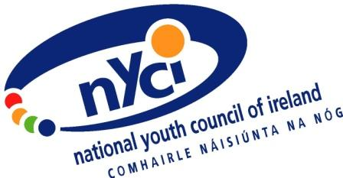

Submission to the Citizens Assembly on

How the State can make Ireland a leader in tackling climate change

By
The National Youth Council of Ireland

August 2017

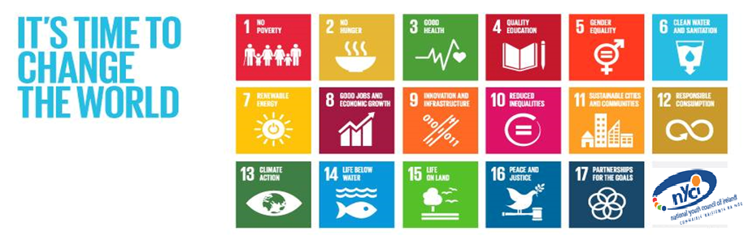

“Together, we can build a world that leaves no one behind, but we must not build it for everyone. We must build it with everyone”
– UN Youth Delegate for Ireland

Introduction
The National Youth Council of Ireland is a national organisation which represents and supports community, voluntary and not for profit youth organisations in Ireland. Founded in 1967, we currently have 50 members across Ireland which represents the scope, scale and diversity of the youth work sector. At a conservative estimate, these organisations touch the lives of almost to 400,000 young people in Ireland. In turn we work in partnership with other local, national and European organisations to deliver strong outcomes and results that positively impact and support young people in Ireland and internationally.

Our work is informed by:
- NYCI Strategic Plan
- National Youth Strategy (NYS)
- Better Outcomes Brighter Futures (BOBF)
- Youth Work Act 2001
- Children First
- Irish Aid Development Education Strategy
- European Youth Policy
- United Nations Convention on the Rights of the Child (UNCRC)
- And related programme policy areas

- We believe that all young people have a right to be supported to develop a sense of belonging, competence, empowerment and usefulness.
- We believe that a strong and vibrant youth sector has a critical role to play in engaging all young people, especially those who are disconnected from the mainstream, and to work alongside them in building lives that are active, productive and resilient.
- We believe better outcomes are achieved when young people are involved in making decisions that affect them.
- We believe in young people being active participants in their communities (active citizens). This is good for community and good for individuals.
- We value volunteering and the vital role it plays in a healthy vibrant community.
- We value the diversity of the voluntary youth sector and believe that is a key strength.
- We believe that a fair and just society is one where young people are valued where there is a commitment to justice; a belief in the interdependence of lives and a sense of solidarity that comes from people acting together; a strong commitment to freedom; and, a strong engagement with the ecological values of harmony and balance with nature.

Recommendations
- Young people must be recognised as active global citizens.

- Young people and youth organisations must be supported and resourced to ensure they can fulfil their role as leaders in tackling climate change. The non-formal youth sector is well placed to support the National Dialogue on Climate Change and the delivery of quality Development Education, using their unique knowledge, skills, interactive and action-based approaches to engage the wider public on the issue of climate change.

- Development Education should be properly (financially) resourced and recognised across government as a gateway through which young people and those who work with young people are empowered to analyse, reflect on and challenge at a local and global level, the root causes and consequences of hunger, poverty, injustice, inequality and climate change; presenting multiple perspectives on global justice issues.

This will support greater global solidarity and social cohesion enabling people to take action locally and globally, contributing to transformation in the social, cultural, political and economic structures which affect all our lives.

- Young people work in Ireland's energy, transport and agriculture sectors and NYCI believes that young people should be involved in shaping a new future for Ireland in these areas in particular through consultation and exploration of issues, alternative employment opportunities and innovations, and solutions.

- The Irish Government must lead on tackling climate change by achieving the targets and recommendations found in the 2030 Agenda for Sustainable Development (SDGs) (http://www.youthdeved.ie/transforming-our-world-2030-agenda-sustainable-development), the Paris Agreement on Climate Change
(http://unfccc.int/paris_agreement/items/9485.php) and the UN Resolution on Youth, Peace and Security (https://www.youth4peace.info/UNSCR2250/Introduction)
http://www.youthdeved.ie/coalition-2030-launch

- Ireland has yet to release its Sustainable Development Goals National Action Plan and will report to the UN in July 2018 on SDG progression. Together with Coalition2030, NYCI is calling for:
  - An ambitious National Action Plan led by the Department of An Taoiseach, involving all government departments to steer, implement, monitor, and report on the SDGs. This Plan needs to emphasise the interlinked nature of the Goals ‐ linking for example, agriculture and climate change to trade policy and global poverty;
  - An Inclusive SDG Monitoring Forum in which civil society, and in particular those vulnerable groups – both Irish and internationally – who stand to gain or lose most from Ireland’s work on the Goals, are fully represented;
  - Increased Financing for Development to support delivery of the SDGs. We call on Government to commit the resources required to achieve the SDGs, both at home and internationally. Only then will the National Action Plan work for the most marginalised and vulnerable. Scaling up public engagement will be important in order to ensure everyone is part of this new movement and that we build an enhanced citizenship through Coalition2030. A key indicator of Ireland’s commitment will be a clear and credible plan to reach the UN ODA target of 0.7% of GNI http://www.youthdeved.ie/coalition-2030-launch

We must all work together to safeguard the future for people and for planet, so no one gets left behind.

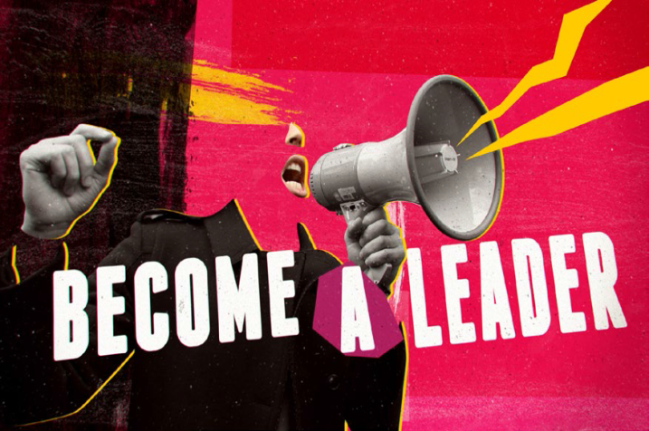

Young people will be the torchbearers of the next world development agenda through 2030. We must ensure that, while protecting the planet, we leave no one behind.
– UN Synthesis Report for the SDGS, December 2014

Young People as a Key Population to lead the fight against Climate Change

- Today, young people aged 10 to 24 make up one quarter of the world’s population - 1.8 billion people – the largest in world history.

- In Ireland, one third of the population are under 25 years and particularly those aged 10-24 years represent 18.3% of the total population of 4.59 million people.

- It is estimated by the United Nations that close to 90% of the world’s youth live in developing countries (some of the poorest nations on the planet).

- More than 500 million young people aged 15-24 live on less than $2 a day.

- Some 74 million young people are unemployed and more than 600 million jobs need to be generated globally (including Ireland) by the year 2030.

- By 2050, with a projected increased global population of 9.6 billion, we would need the equivalent of almost 3 planets worth of resources to sustain our way of living, if our current consumption and production patterns remain the same.

Sources: http://www.un.org/youthenvoy/youth-statistics/
https://www.dcya.gov.ie/documents/publications/20151008NatYouthStrat2015to2020.pdf

These statistics begin to tell a story about the demands there will be on the world to deliver what we consider to be quality lifestyles for these young people as they progress through their lives. It is therefore important that young people are involved and engaged in how we progress as a society and as a planet as we tackle what is probably the greatest challenge facing us all. Young people represent an important cohort of people who as a collective have the ability to take a key leadership role in tackling climate change to enhance and secure the world in which we live, their own lives and the lives of others locally, nationally, and globally.

According to Ojala and Lakew (April 2017: 1), and Mauger, Minujin, and Cocco-Klein (2016: 1), there are a number of reasons why young people are an important group to consider when mapping out how best to deal with and lead on tackling Climate Change.

- Young people of today are the future leaders, decision-makers, and researchers of tomorrow who will have future influence on how the world develops.

- Children and young people are particularly vulnerable to climate change due to:
  - the extent to which children and young people live in a physical location that is vulnerable to drought, floods, extreme weather events and sea level rise. Estimates by UNICEF indicate that 160 million children live in drought-prone areas, and half a billion more live in zones at risk to high floods and severe storms.
  - vulnerability to hazards due to a lack of resources, poverty and marginalisation. Families without adequate incomes and assets, protective infrastructure and housing, access to basic services, and inadequate nutrition and clean water, face the greatest risk in a changing climate.
  - today’s children, young people and future generations will bear the brunt of environmental impacts, creating an inter-generational injustice without precedent.

All children and young people are at risk from climate change but it is those who live in greatest poverty and in the most exposed places that face the greatest risks. More than just passive victims, these young people, often with the support of their caregivers and communities, also represent agents of change and have consistently demonstrated the capacity to devise local solutions, participate in global conversations and contribute to a safe and sustainable future.

- It is vital to listen to and learn from young people as it is they who will most probably bear a larger burden of the negative consequences of climate change than older people.

- Young people are consumers and citizens of today and like others, are contributing to the climate problem through living and consumption patterns.

- By involving young people in education and communication approaches around climate change, we would support young people to share their knowledge of climate change happening in their own areas and also potentially support innovative solutions that they may have to tackle such climate change problems.

- There are researchers who argue that climate change is not only a societal and environmental problem, but also a health, well-being, and psychological threat. In this regard, young people, especially children, are perhaps more vulnerable to experiencing negative affect and low well-being in relation to climate change.

- Finally, young people are unique in that many are involved in educational systems – formal and non-formal - and thus are relatively easy to reach with information and for solutions about climate change. In addition, values, worldviews, and identities are still not wholly internalised in this age group, so young people, in general, are usually more open to new ways of responding to this problem.

http://climatescience.oxfordre.com/view/10.1093/acrefore/9780190228620.001.0001/acrefore-9780190228620-e-408 and http://www.eldis.org/document/A100437

The Youth Sector in Ireland
There are almost 400,000 young people involved in a variety of different ways in youth work and half of these come from disadvantaged backgrounds. 2 in 5 young people are involved in a club or society.

According to the ‘Assessment of the Economic Value of Youth Work’ (NYCI, 2012: 13), the youth work sector involves 40,000 adult volunteers with 1,400 professional youth workers. The level of participation from young people and the volunteering of adults is part of our culture in Ireland. It is a real strength of the youth sector. This is in turn, creates a different DE/youth work context to our European neighbours.

There are a broad range of actors working/partnering on DE/ESD/human rights education in the youth sector, including youth, development, development education and formal education organisations – nationally and internationally.

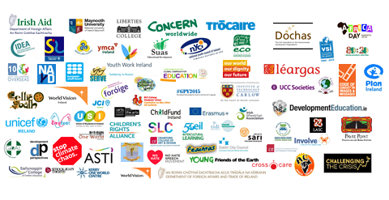

The graphic above highlights the diversity of the youth sector, the diversity of development education provision with diverse groups of young people. Each actor has their own valuable role to play.

The Youth Sector must be adequately supported to ensure young people are aware of the issues and supported to bring about change personally, locally, nationally, and globally.

Young people may be involved in Development Education through uniform organisations, faith-based, environmental, outdoor education, international volunteering, welfare and health, travelling community, equality, Irish language, rural youth, independent/local/regional youth services, civic organisations, and multi-service organisations. Non-formal/youth sector Development Education also takes place at university level and formal education courses support youth workers at third level and community level. Through their engagement with the youth sector, young people develop the confidence, resilience, capacity and critical thinking skills they need to be involved in society, to reach their potential and to become change makers – locally and globally.

The youth sector is different from the formal sector in that that young people participate on a voluntary basis, largely outside of school, and are active partners in making decisions, planning programmes, and setting priorities for action through interactive methodologies and particularly experiential learning. Much of the work undertaken is influenced by Freirean ideas of consciousness-raising and John Dewey’s idea of education being a search for meaning and about the making sense of things.

The methods and approaches allow young people and particularly marginalised young people to access Development Education and to have their voices heard.

Organisations within the sector are experts in both DE and Youth work and who work together in Ireland and with European/global partners to support equality, social inclusion and solidarity.

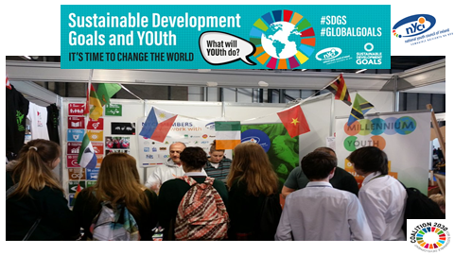

Development Education
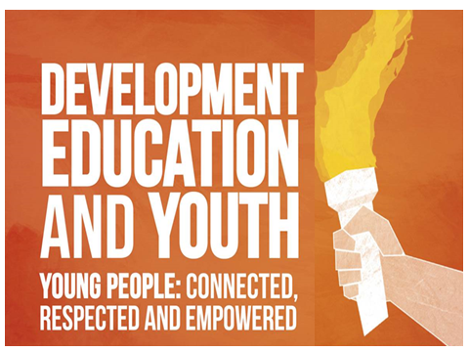

The National Youth Council of Ireland is of the view that Development Education is an important route through which young people can be supported to tackle climate change.

Development Education is a lifelong educational process which aims to increase public awareness and understanding of the rapidly changing, interdependent and unequal world in which we live. By challenging stereotypes and encouraging independent thinking, Development Education helps people to critically explore how global justice issues interlink with their everyday lives. Informed and engaged citizens are best placed to address complex social, economic and environmental issues linked to development.

Development Education empowers people to analyse, reflect on and challenge at a local and global level, the root causes and consequences of global hunger, poverty, injustice, inequality and climate change; presenting multiple perspectives on global justice issues.

Development Education inspires global solidarity by supporting people to fully realise their rights, responsibilities and potential as global citizens. Development Education enables people to take action locally and globally -the understanding or theory of change being that such action will contribute to desired transformations in the social, cultural, political and economic structures which affect their lives and the lives of others.

Climate change affects our everyday life and future on this planet. Issues that are climate change issues include poverty, hunger, health and well-being, education, gender equality, water and sanitation, affordable and clean energy, employment and economic growth, industry and innovation, inequalities, sustainable cities and communities, consumption and production, climate action itself, life below water, life on land, peace and justice, and partnerships to ensure a sustainable present and future for people and for planet.

By engaging with Development Education, learners develop the values, knowledge, skills and attitudes necessary to become active global citizens and advocate for change.

(Source: Irish Aid Development Education Strategy 2017-2023) https://www.irishaid.ie/media/irishaid/allwebsitemedia/60aboutirishaid/IA-DevEd-Strategy-English.pdf)

Sustainable Development Goals
The United Nations Sustainable Development Goals 2015-2030, to which Ireland has committed, provide the first international framework to guide and support active global citizenship at both national and international levels, enabling people to become active global citizens in the creation of a fairer, more just, more secure and more sustainable world for all.

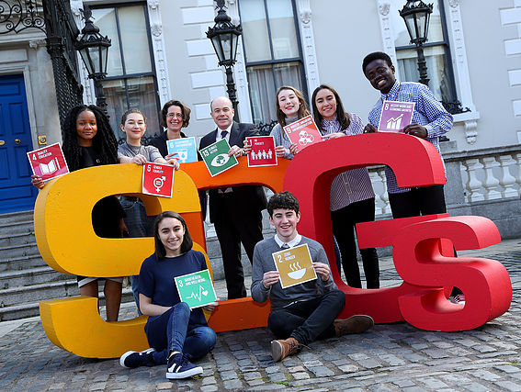

The Sustainable Development Goals (SDGs) are a new blueprint for the world and provide a unique opportunity to address the most urgent and fundamental needs of millions of people in Ireland and around the world – people who have the right, and who seek the means and the freedom, to live their lives in dignity. We cannot continue to do business as usual but take this opportunity through the 17 goals, 169 targets and 230 indicators to ensure we are successful, for people and planet, so no one is left behind.

The 17 Sustainable Development Goals can be sub-divided into 5Ps: – People; Planet; Prosperity; Peace; and Partnership.

The SDGs acknowledge the important role of Global Citizenship Education including Development Education in building the conditions for a more peaceful, fair and sustainable world under Target 4.7, which calls on countries to “ensure that all learners acquire the knowledge and skills needed to promote sustainable development, including, among others, through education for sustainable development and sustainable lifestyles, human rights, gender equality, promotion of a culture of peace and nonviolence, global citizenship and appreciation of cultural diversity and of culture’s contribution to sustainable development.’’

The European Youth Forum notes that sustainable development is a process and practice of vital importance for young people and future generations, for environmental, economic and social sustainability, the present and the future of the planet and for intergenerational solidarity. Following the adoption of the 2030 Agenda for Sustainable Development (SDGs), the Paris Agreement on Climate Change and the UN Resolution on Youth, Peace and Security, there is unprecedented momentum for working towards sustainable development.

Yet this momentum needs to be translated and pursued within Europe at all levels, where it is not yet being taken seriously enough by governments and institutions. There is an urgent need to raise awareness about the SDGs, what it means for young people, and to work on its implementation.

The Sustainable Development Goals create a context for Ireland to provide quality education on global citizenship. Development Education is an essential component in delivering Ireland’s commitment under Target 4.7 as well as raising awareness of the 17 Sustainable Development Goals and tackling climate change.

Development education strengthens public understanding of the interconnectedness of global and national poverty and inequality, supporting the Irish public to acquire the necessary knowledge, values and analytical skills to understand the global justice focus of each of the Goals and the underlying values and dispositions.

Development Education is therefore integral to the successful delivery of the Sustainable Development Goals, inspiring and enabling people to take action to deliver the Goals at local, national and global levels. We will pursue all opportunities to work in partnership with the relevant government departments to reach Target 4.7 of the UN Sustainable Development Goals through the provision of high-quality global citizenship education.

By combining our efforts and working in a coherent and complementary manner with the international community through the framework provided by the Sustainable Development Goals, Ireland can maximise the effectiveness of its foreign policy, international development policy, Development Education Strategy and other national global citizenship education programmes to build a fairer and more sustainable world for all the world’s citizens.

The Goals represent a plan of action for the next 13 years to transform our world by ensuring the most deprived on our planet overcome poverty and hunger, by reaching the most vulnerable first, by prioritising human rights and empowering women, and by tackling the adverse impacts of climate change.

The Goals are ‘universal’ in nature, meaning they must be advanced here in Ireland as well as through our actions abroad. Between now and 2030, Ireland will be obliged to report on progress and we as civil society, and youth sector in particular, are working together to contribute to that progress.

Development Education and Global Youth Work
Global Youth Work and Development Education can support young people and those working with young people to take their place as informed and empowered global citizens in the world. Development Education must be embedded in organisations through education as well as a policy and practice approach.

DE and Global Youth Work aims to support young people and those working with young people to increase their awareness and understanding of the interdependent and unequal world in which we/they live, through a process of interactive learning and education, debate, action and reflection. DE challenges perceptions of the world and encourages people to act for a more just and equal society at a personal, local, national and international level. For NYCI, quality DE is key and shares many of the same principles as good youth work. These include starting with and valuing young people’s own views; learning through participation; promoting equality, responsibility and mutual respect.

DE and Global Youth Work issues can be critically addressed through the lens of the five faces of globalisation which, according to Dr. Momodou Sallah are: Economic: Trade, economics, transnational corporations; Environmental: Carbon emissions, ozone layer, rain forest, water, global warming, flooding, quality of air, health, etc; Cultural: People’s way of life, food, music, media, internet; Technological: all means of communication that brings the world together – internet, mobile phones, newspapers, magazines, air travel, etc; Political: Democracy, right and wrong, world views, world order, what is and what is not human rights abuse, etc. All of these have a bearing on climate change – the problems and the solutions.

NYCI has produced a series of resources that support young people and those working with young people to tackle some of the key issues of our time. These can be found:

Development Education: http://www.youthdeved.ie/publications

Children and Young People’s Rights: http://www.oneworldweek.ie/sites/default/files/SettingOurSightsOnRights2014.pdf

NYCI also runs One World Week which takes place in the third week in November each year and is a focal point for the youth and other sectors to take action on local and global issues relating to the lives of young people. See: www.youthdeved.ie and www.oneworldweek.ie for more information. NYCI also coordinates the UN Youth Delegate Programme http://www.youth.ie/nyci/Delegates-Action and supports the engagement of young people from across Ireland through its Young Voices work http://www.youth.ie/youngvoices

Ireland must support young people (and other cohorts) to understand the world in which we/they live by providing them with tools through which they view the issues of the world and work through how that issue may be resolved.

Conclusion
This is an exciting time in world history and the youth sector (through the new Sustainable Development Goals and other global, national and local opportunities), believe that we are rightly positioned to make a difference and potentially transform how Development Education can be used and seen to engage young people and those who work with young people in Ireland and globally to tackle climate change.

The youth sector has no doubt that young people want to be involved, they want their voices heard. Young people want to take action and are passionate about tackling climate change. It is up to all of us, educators, funders, organisations, researchers and policy makers to work together to develop pathways through which young people, those who work with young people, those who educate the educators, and others can engage on what is the issue of our time.

In making this submission to you, the Citizen’s Assembly, we are setting out to work with you and with others who have made submissions to you (Stop Climate Chaos, Trocaire, Concern, etc) to support Ireland become a leader in tackling Climate Change. It is our view that young people are a key cohort that must be considered and supported to take on climate change so they can bring about sustainable change for a sustainable future – for people and for planet.

In a special address to young people, United Nations Secretary General Ban Ki-moon made three calls to action to the world’s young people:
- Help us drive sustainable development that is people-centred and planet-sensitive
- Fight injustice and inequality with solidarity so no one is left behind
- Be an active global citizen

With your support and thanks to your initiative in calling for this discussion on climate change, this is what we hope will happen.

It is time to change the world.

Submission from the National Youth Council of Ireland
Contact name: Valerie Duffy
Name of your Organisation: The National Youth Council of Ireland (NYCI)
Address: 3 Montague Street, Dublin 2
Contact Phone Number: (01) 478 4122 Contact
Email Address: deved@nyci.ie

